Online Food Ordering Database – Final Paper

Justin Stewart

CPT310: Database Systems & Management

Prof. Scudder

May 16, 2022

**USER GUIDE**

1. **Introduction**

This document provides all of the necessary information to run the CreateDB.sql and PopulateData.sql files necessary to create an FoodOrderingOnline Database. The documentation covers all of the required programs and installation instructions, as well the necessary steps that must be taken to successfully deploy the database utilizing the aforementioned and provided SQL files. There is also a demonstrative video included at the end where I demonstrate all of the steps provided below step-by-step.

1. **Getting Started**

In order to begin creating, populating, and manipulating databases of any kind, we must install the tools necessary to do so. First, I highly recommend you install the following applications: XAMPP Control Panel 3.0 and MySQL Workbench. You may use any SQL editor you are comfortable with, but I recommend the usage of MySQL Workbench as it produced the best results throughout the creation of the database.

* XAMPP Control Panel 3.0 allows users to create their own locally hosted SQL database server to run the attached scripts for both creating and populating the database. Latest download: <https://www.apachefriends.org/download.html>
* MySQL Workbench is a visual database design tool that allows users to write and run SQL code on their server.
* Latest Download: https://dev.mysql.com/downloads/installer/

To install both XAMPP and MySQL Workbench, go to the links provided above, select your system’s operating system, and simply click next through the installations until the program is successfully installed in your desired location.

**IMPORTANT NOTE:** When you reach the “Components” section of XAMPP’s installation, I recommend leaving all boxes ticked as this allows the program to install all necessary dependencies for whatever the user may use the program for. It even installs phpMyAdmin for you!

1. **What’s Next?**

Upon installing the two recommended softwares, open XAMPP first, and click the buttons labeled “Start” on both “Apache” and “MySQL” under the “Modules” section of the program. It is important to note that your servers WILL NOT run unless both of these modules are started. Once started, click on the “Admin” button next to “MySQL”, and a phpMyAdmin webpage will appear. This webpage is your database manager, where you can create, delete, or alter databases. This webpage is particularly useful for regularly viewing the changes made to the database.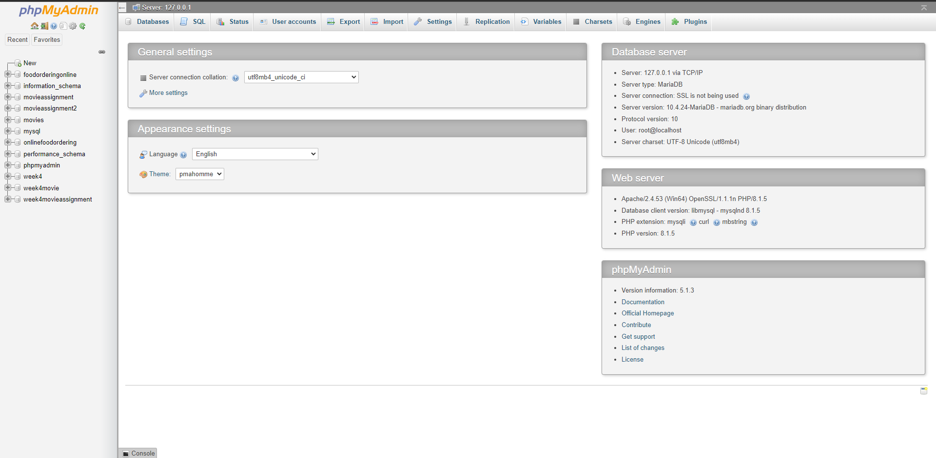

**Note:** Users may find this webpage more user-friendly than utilizing MySQL Workbench, and may certainly insert all of the SQL statements from the attached .sql files to this website.

1. **MySQL Workbench**

Now that your database servers are online and you have access to your web-based database manager, run MySQL Workbench. Upon starting MySQL Workbench you will be greeted with the welcome screen. In order to make changes to a database, we must connect to the database first. To do this, make sure the dolphin logo at the top left is selected, then click the “+” next to “MySQL Connections”.

Upon clicking the “+” we are prompted with a new window to set up a new connection. The information present here should automatically populate with the correct data from XAMPP as long as it is running, but make sure that the values listed under “Port(s)” in XAMPP match the “Port” in the MySQL window. If they don’t match, correct them so that they do. All that is left is to give the connection a name, in our case this will be FoodOrderingOnline, and click “OK”, dismissing any errors that may follow.

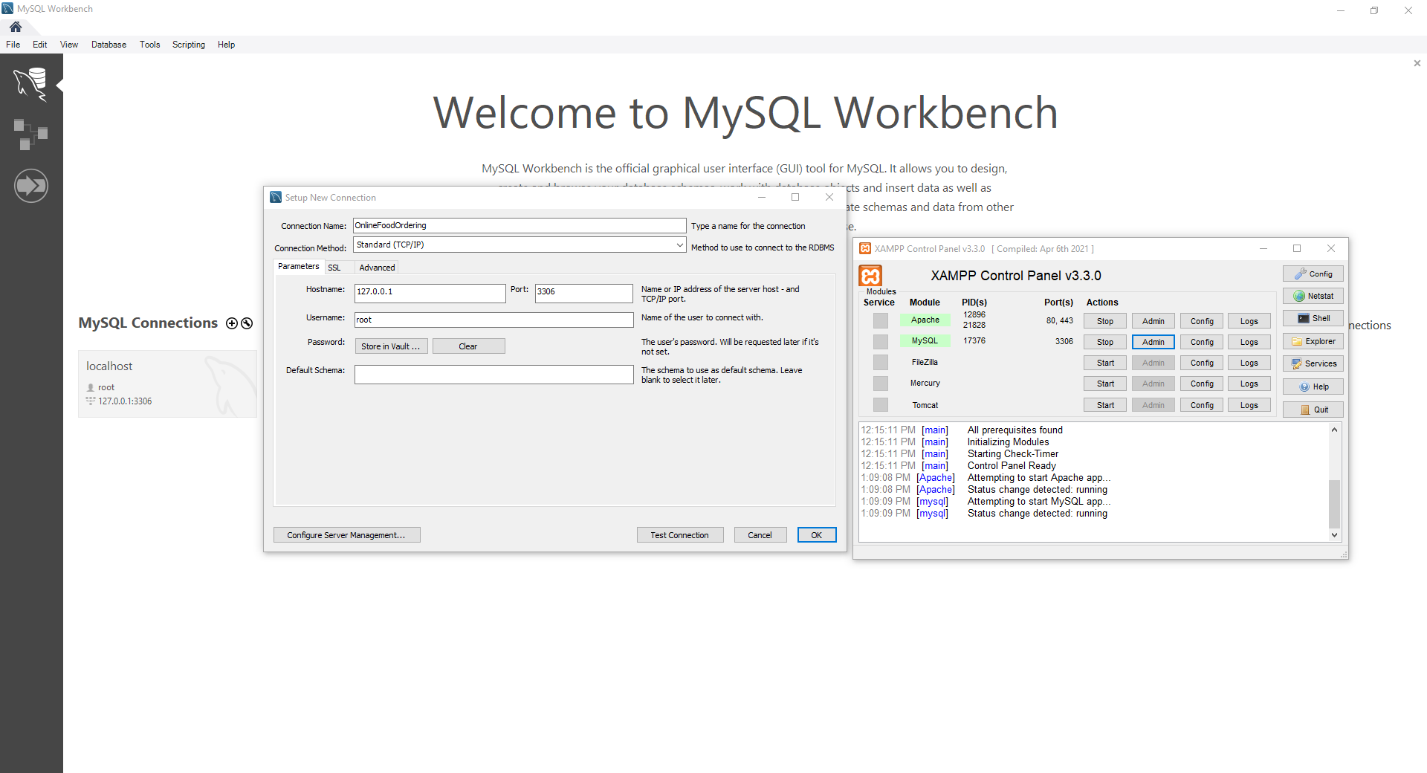

Once the connection is properly set up, it should appear under the alias it was assigned. In our case, the resulting home screen will appear as such: 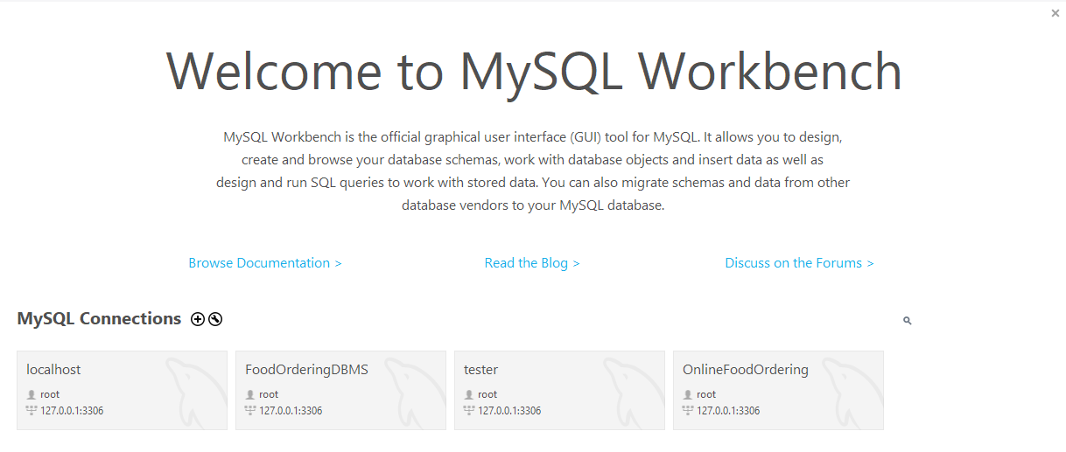

Simply double click on the connection you have created, and you will be greeted with your first SQL Query window. Please follow the next steps to utilize the CreateDB.sql and PopulateData.sql files.

1. **How To Use The CreateDB.sql and PopulateData.sql Files**

Once in your first SQL Query window, click on the blue folder icon stating “Open a script in this editor”.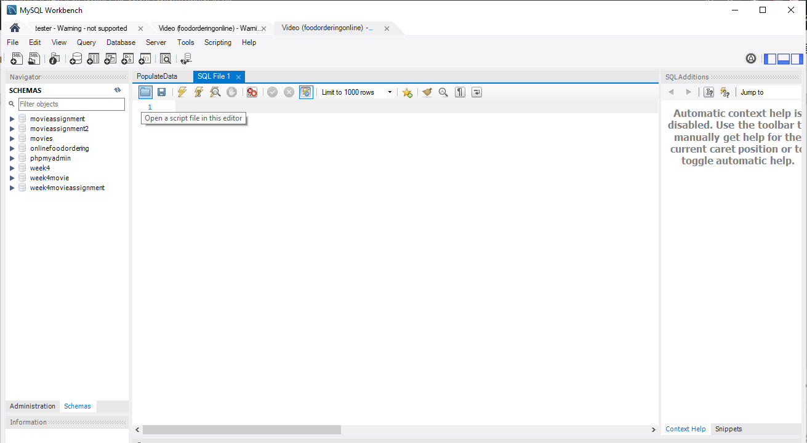

A new window will appear, where you will be prompted to navigate to where you have saved the CreateDB.sql and PopulateData.sql files. Simply navigate to where you’ve saved the CreateDB.sql file, click on CreateDB.sql to import all of the SQL script, and click the first yellow lightning bolt 2 icons over from the folder icon to run the script. Voila! Given no errors in the output, you have successfully created the FoodOrderingOnline Database!

With the database created, you may notice that there are no values in the tables at first. Don’t worry, this comes from the PopulateData.sql file. In order to populate the newly created database, simply repeat the process used to import the script for CreateDB.sql, but select PopulateData.sql instead. To clarify, click on the same blue folder as before, navigate to your new PopulateData.sql file in your target directory, and click the yellow lightning bolt icon 2 icons to the right of the folder.

1. **Success!**

Once the PopulateData.sql file has successfully run, that’s it! You’ve successfully created and populated the FoodOrderingOnline Database!

1. **USER GUIDE VIDEO**

If you happened to run into any unexpected errors or issues throughout the process, please review the video linked below, where I personally walk through the steps necessary to successfully create and populate the FoodOrderingOnline Database.

Link To User Guide Video: <https://screencast-o-matic.com/watch/c3hbV3VrTVY>

1. **ER Diagram Of Entire Database**

**Note:** I know it wasn’t requested, but just in case I wanted to include an ER Diagram of my entire database.

